MICHAEL MAGUIRE

Nationally Accredited Mediator and Family Dispute Resolution Practitioner
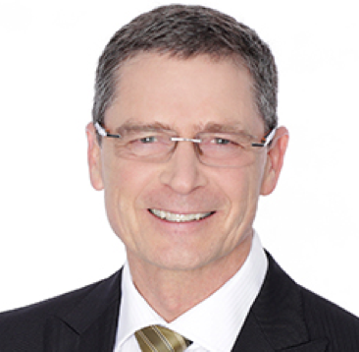 | - Extensive experience (30 yrs +) in Family Law  - Extensive experience in property settlement mediation  - Experience in parenting (including child inclusive) mediation  - Child focused - works towards achieving the best possible outcomes for children involved  - High level mediation skills  - Highly recommended by lawyers  - Mediation experience appropriate to New Zealand & Australia  - Accredited FDRP  - Member - Resolution Institute  - Member - Family Law Section New Zealand and Australia

Private Mediation – Australia and New Zealand Property and Parenting Mediation Services

Skilled, empathetic and experienced, Michael is passionate about helping separating couples to find their own resolution in a timely and cost effective way; avoiding expensive and lengthy legal proceedings.

Michael guides the parties through the mediation process with respect and dignity. He has a calm and non-judgemental manner. He is skilled in the mediation process – guiding negotiation, exploring issues central to the conflict and promoting communication.
Experience
- Family Law Partner - Prior to full time practice as a mediator, Michael’s 10 years as a Family Law partner in Queensland, has given him the background necessary for successful dispute resolution and mediation.
- University Lecturer - Michael is a successful educator in Family Law, contributing as a lecturer and Course Co-ordinator at QUT.
- Mediator and FDRP – Long term practice in mediation and on a full time basis since 2014.

Testimonials  “I endorse Michael Maguire as a mediator. I have been fortunate to know Michael since 1999, and have worked with him in a professional capacity since 2010. I find Michael to be an excellent communicator who is able to get to core issues quickly and make emotionally complex issues simple. He shows an appropriate amount of empathy, while working hard to achieve a resolution at mediation rather than navigate the litigation pathway.  Family Law Acredited Specialist, Toowoomba | “Michael brings great experience with the benefit also of a diverse and broad background in the law. He has empathy and is impartial, and has honed the skill of bringing people to a good and safe resolution whilst also focusing on their future.  My clients feel he's as much invested in reaching an outcome as they are.”  Doyles Guide, Preeminent Family Lawyer
Volunteer Work and Governance  Chair of the Board of Directors - TASC National Ltd  Michael’s work on the Board of TASC National has been a long-term undertaking. He believes that the role of the organisation is vital to the continued health of the community in Toowoomba and the South West. During the time that he has been involved, the service has developed from a small volunteer legal service to a large multi-faceted organisation delivering varied and vital advocacy and support services to the community. Michael is humbled to have been awarded an Honorary Life Membership of TASC. www.tascnational.org.au | Councillor and Executive member; Treasurer - National Ethnic Disability Alliance (NEDA)  NEDA is the national peak organisation representing the rights and interests of people living with disability, their families and carers, from culturally and linguistically diverse and non-English speaking backgrounds.  www.neda.org.au
Relevant Qualifications
- Solicitor, Queensland, 1980
- Grad Dip Education, Catholic College of Education, Sydney, 1987
- Master of Laws, University of Queensland, 1991
- Dispute Resolution Centre – Mediation Certificate, Bond University, 1992
- Mediator of Disputes Certificate, Queensland Law Society, 2006
- Graduate Diploma of Family Dispute Resolution, QUT, 2014
- Nationally Accredited Mediator, 2014
- Family Dispute Resolution Practitioner (FDRP), Federal Attorney General’s Dept, 2015

